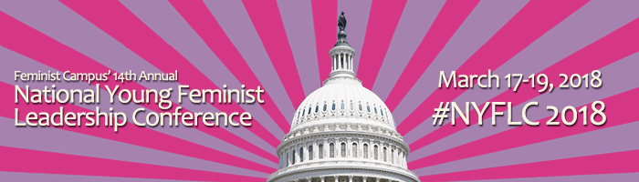

Accommodation Request Form for Feminists with Disabilities
Feminist Campus’ National Young Feminist Leadership Conference aims to be as inclusive and accessible as possible to feminists of all ability levels. If you are attending NYFLC and require accommodations, please complete this form with as much detail as possible and the Feminist Campus team will reach out to coordinate the details of your accommodations.
Please send the completed form to nyflc@feminist.org along with any questions about the conference or the hotel.

Full Name:
Pronouns:
Email:
Phone/TTY:
(Please indicate your preferred method of communication)
University/College:
Type of accommodation:

